Converting AutoCAD files to COLLADA format Method II

JaamSim uses *COLLADA (.dae*) type files to load 3D content. Since AutoCAD cannot export directly into *COLLADA*, we must first convert the original CAD files (.dwg) before opening them up in JaamSim. Another way this can be done is by opening the AutoCAD files in *Bentely Navigator* and exporting in *COLLADA* form. This set of instructions runs through the process of converting and opening AutoCAD files in JaamSim.

1. Open *Bentley Navigator*. Cancel the *project wise log-in* box that appears.
2. Select the AutoCAD (.dwg) file you wish to work with.
3. 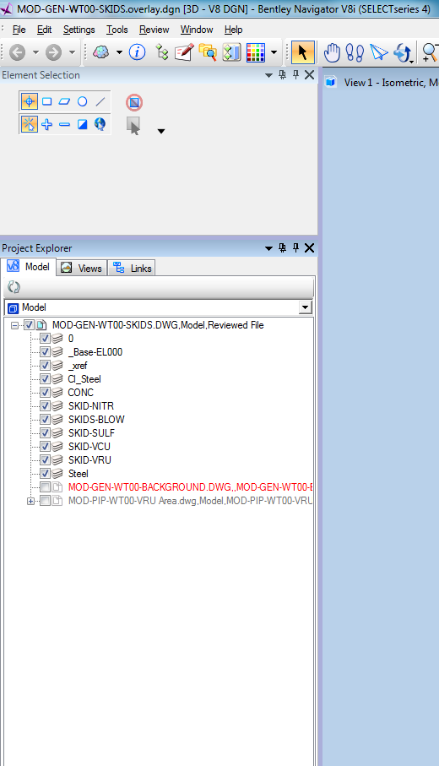Select the **Project Explorer**. Under your file, make sure there are **no other files selected**. Navigator tends to include related project files when exporting. This causes the COLLADA files to be unnecessarily large.

Project Explorer

Keep file components checked.

Uncheck any other files included in the parent file.

1. Select **File 🡪 Export 🡪 Collada**. An export settings box will appear. Make sure all boxes are left unchecked elsewise your file will be too large to run efficiently. Change all other settings to your discretion. *Note: Stroke Tolerance in theory should control the fineness of the tessellations, however, does not seem to have any effect.*

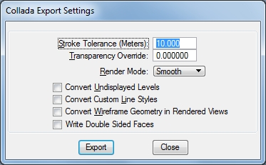

1. **Save** your file and open it in JaamSim.